Centos1 installation time: 2 hours

Centos2 installation time: 1 hour

Centos3 installation time: 20 minutes

SELINUX update:  
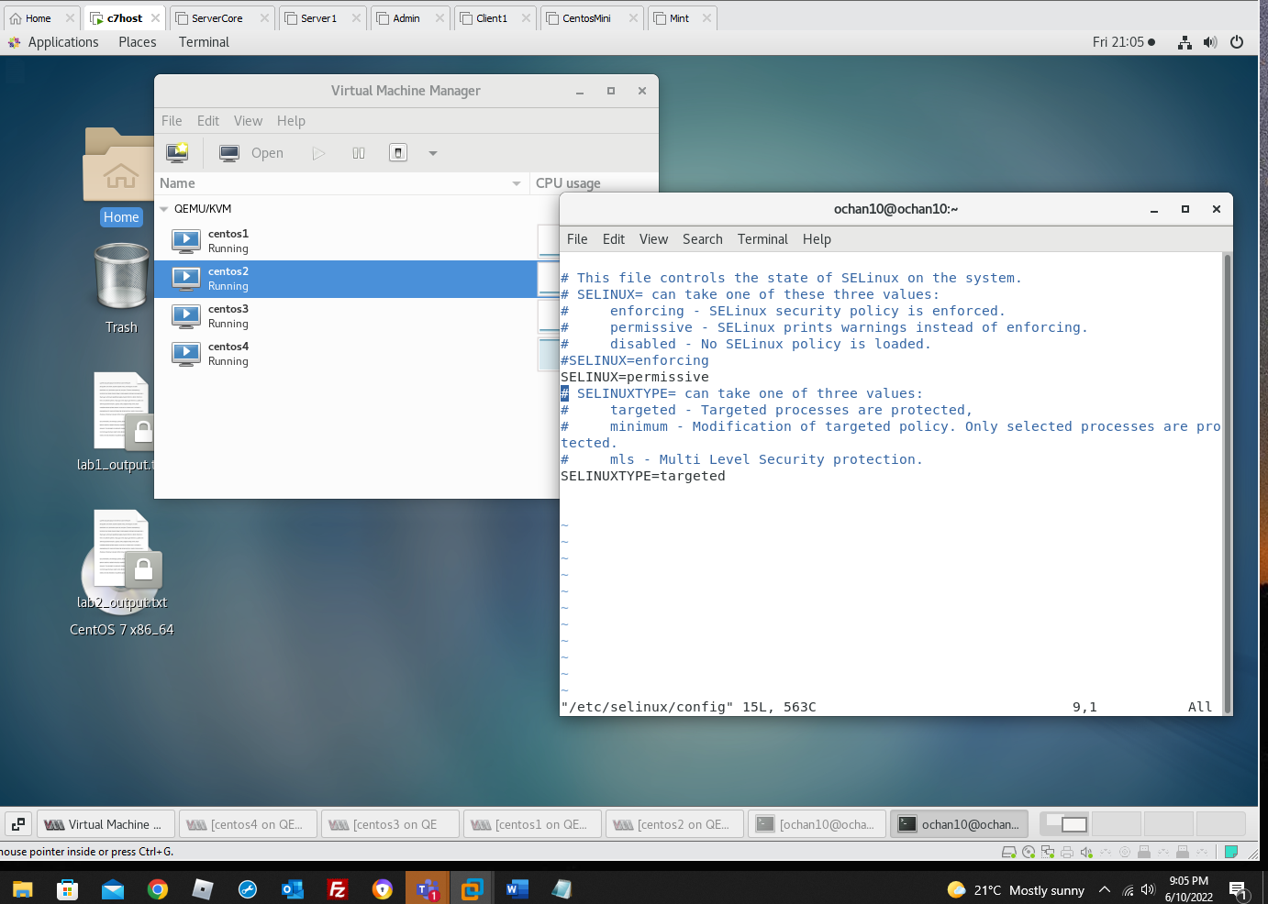

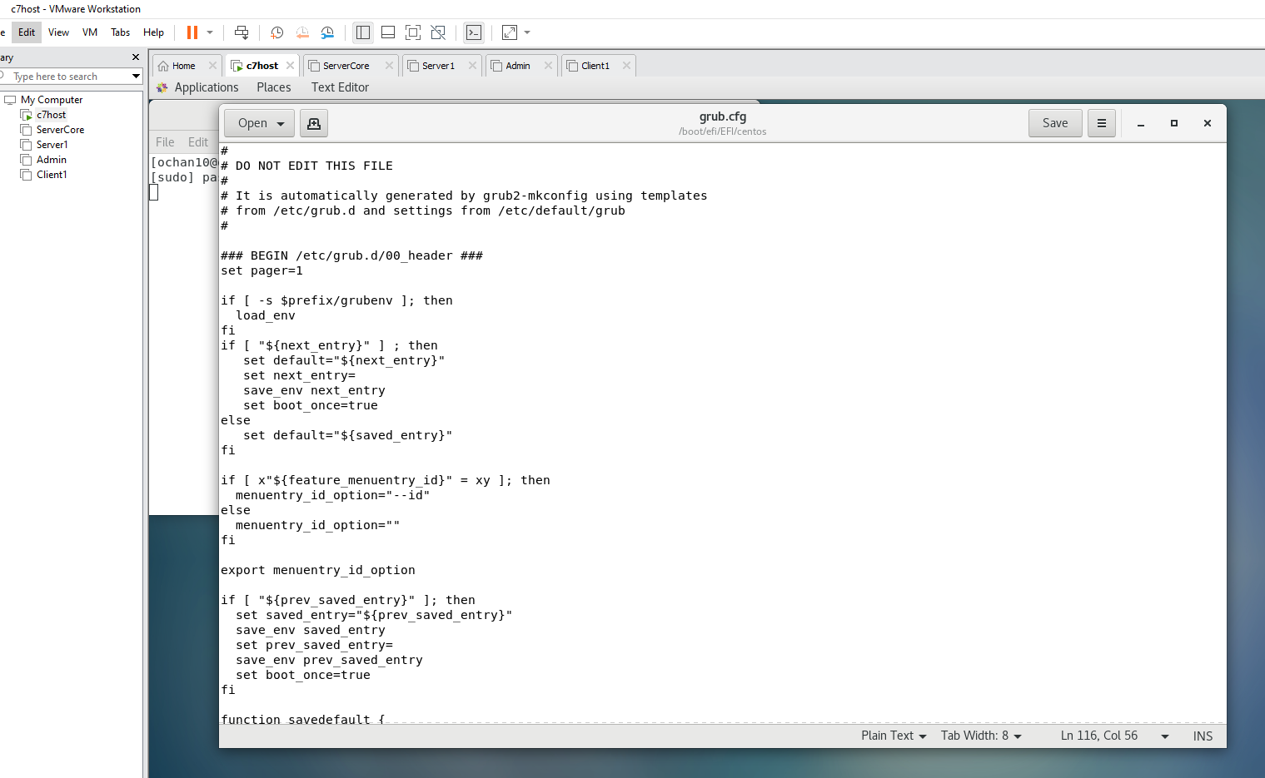

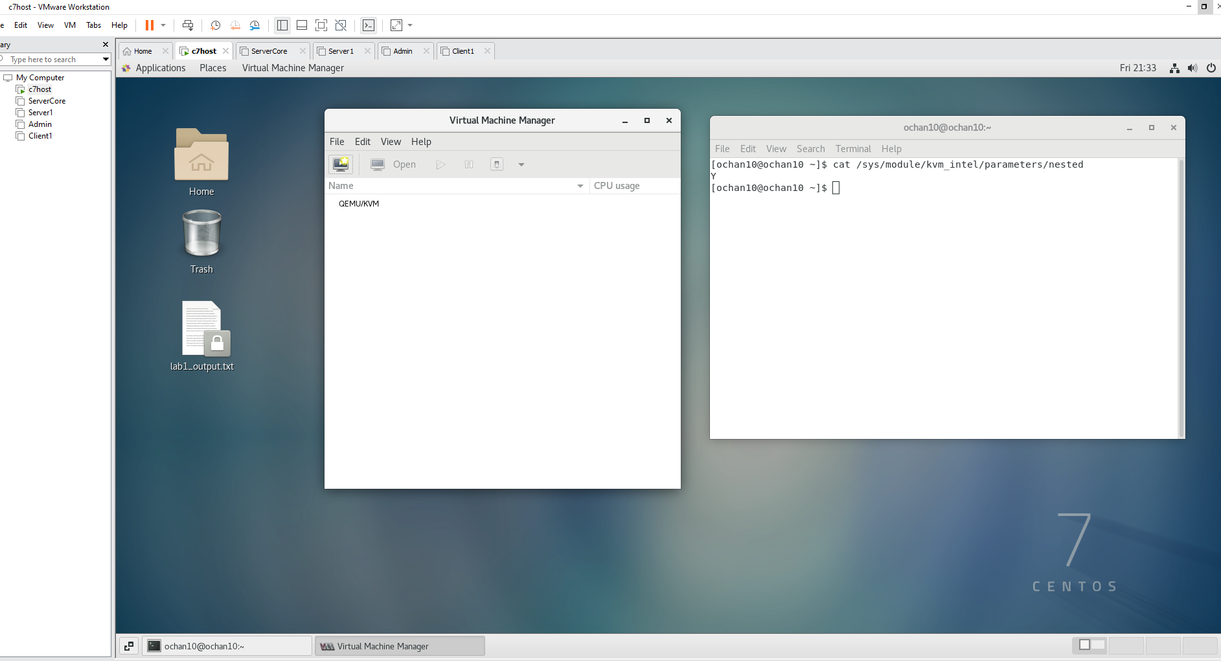

Investigation 2:  
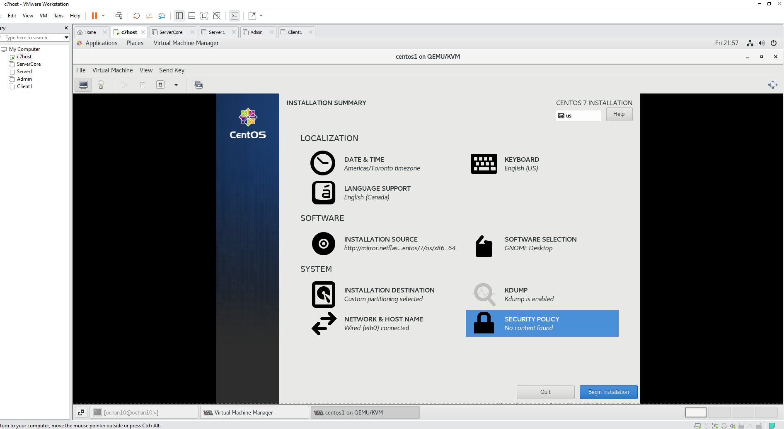

Ks link:

# Kickstart file for C7.0 "centos3" vm in OPS245

# Winter 2021 version by P.C.

# Fall 2018 version by C.J - External 2018-09-16

# Based on Summer 2015 version A.S.

# Based on Winter 2014 version A.S.

# Based on Beta version - kp Jan 17 2013 Revision 1.32 2012-01-19

#

# For documentation on kickstart options see

# http://www.centos.org/docs/5/html/5.2/Installation_Guide/s1-kickstart2-options.html

#

# First version author: Andrew Smith <andrew.smith@senecacollege.ca>

# Previous version author: Chris Johnson <chris.johnson@senecacollege.ca>

# Current version auther: Peter Callaghan <peter.callaghan@senecacollege.ca>

# Installation or upgrade

install

# Installation source

url --url=http://mirror.netflash.net/centos/7/os/x86_64/

# Language and keyboard type

lang en_US.UTF-8

keyboard us

# Network connection information

network --onboot yes --device eth0 --bootproto dhcp --hostname=centos3

# Root account information

rootpw ops245

# Firewall and permitted services

firewall --service=ssh

# Authentication (password) configuration

authconfig --enableshadow --passalgo=sha512 --enablefingerprint

# SELinux settings

selinux --permissive

# Timezone

timezone America/Toronto

# GRUB bootloader configuration

bootloader --location=mbr --driveorder=vda --append="crashkernel=auto rhgb quiet"

# Disk partitions

# Clear all paritions and set up initial disk label

# Create a boot partition that is 500M in size

# Create a PV that is at least 1M in size and fills whole disk

zerombr

clearpart --all --initlabel --drives=vda

part biosboot --fstype=biosboot --size=1

part /boot --fstype=ext4 --size=500

part --grow --size=1 pv.1

# LVM configuration

# One volume group named "vg_centos3"

# 8GB logical volume named "lv_root" for /

# 1GB logical volume named "lv_home" for /home

# 496 to 992MB logical volume named "lv_swap" for swap space

volgroup vg_centos3 --pesize=4096 pv.1

logvol / --fstype=ext4 --name=lv_root --vgname=vg_centos3 --size=8192

logvol /home --fstype=ext4 --name=lv_home --vgname=vg_centos3 --size=1024

logvol swap --name=lv_swap --vgname=vg_centos3 --grow --size=496 --maxsize=992

# Software repositories to use in addition to installation source

repo --name="CentOS" --baseurl=http://mirror.netflash.net/centos/7/os/x86_64/ --cost=100

# User account

user --name=ops245 --password=ops245 --groups=wheel

# Disable firstboot configuration screens

firstboot --disable

# Shut down the system when installation is done

poweroff

# Packages to be installed

%packages

@base

@core

gpgme

gnupg2

hdparm

glibc-common

-initscripts

ncurses-base

elinks

%end

What happens when the installation is finished?

* After the installation was completed, it shutdown and reboots by itself and wnnt to the login page.
* **Regular-user account name: ops245**
* **Regular-user account password: ops245**
* **Root Password: ops245**

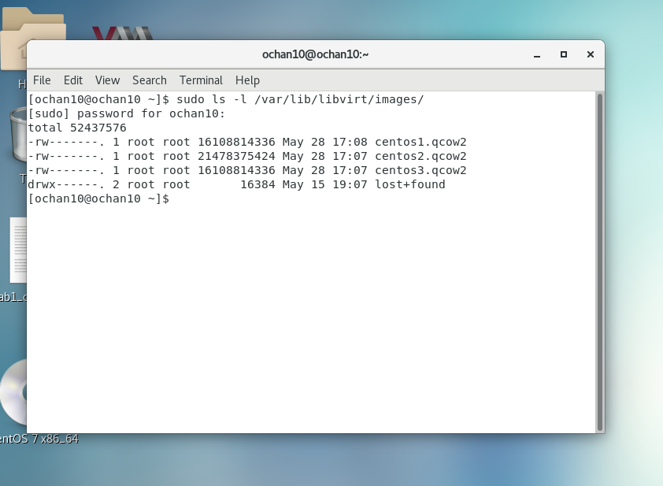

Centos1 ip address:  
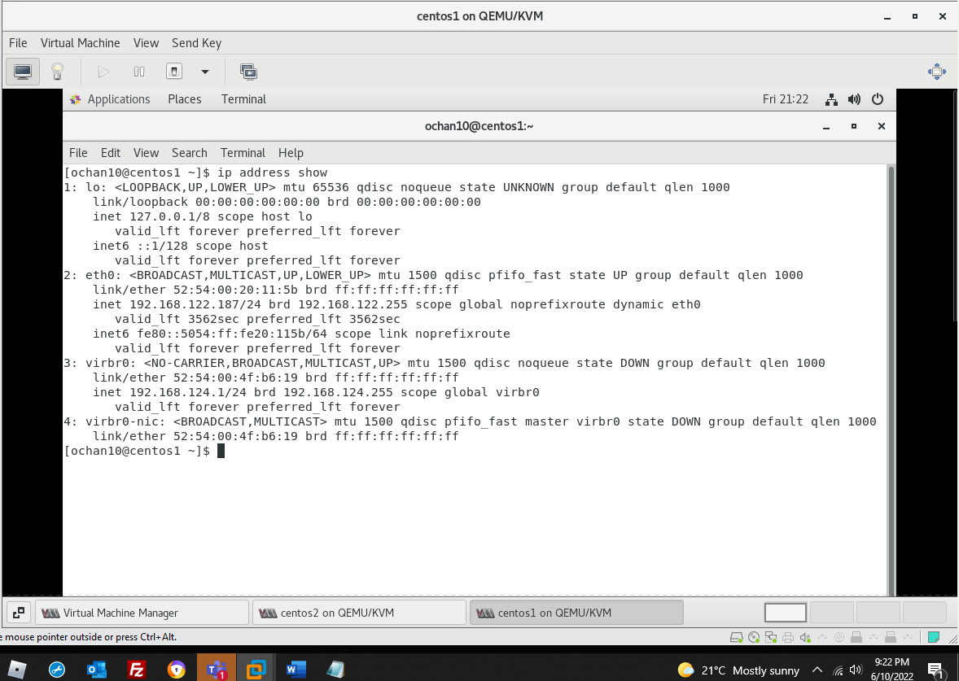

Centos2 ip address:  
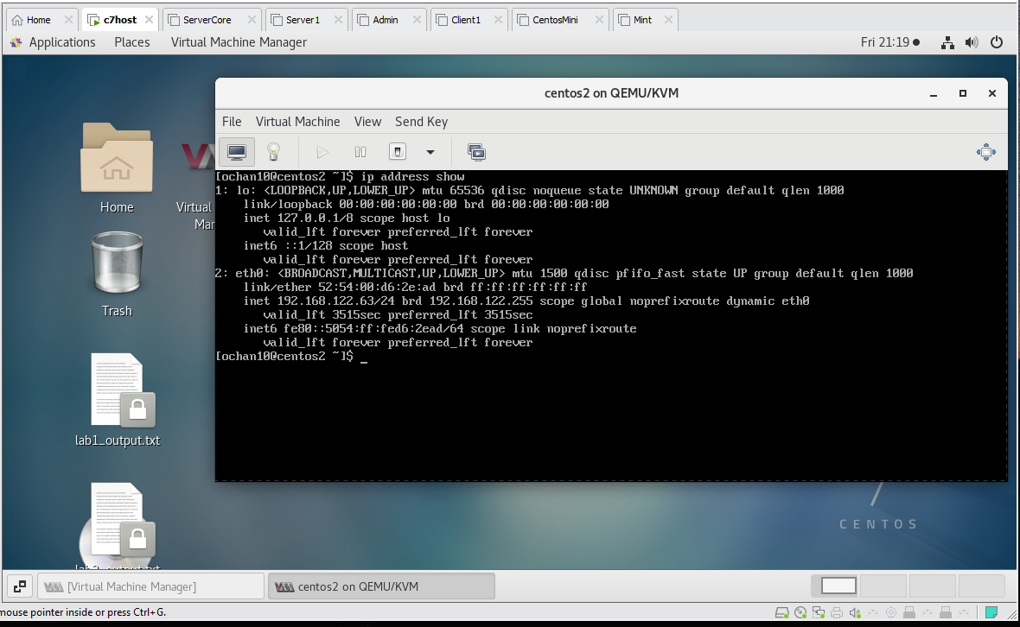

Centos3 ip address:

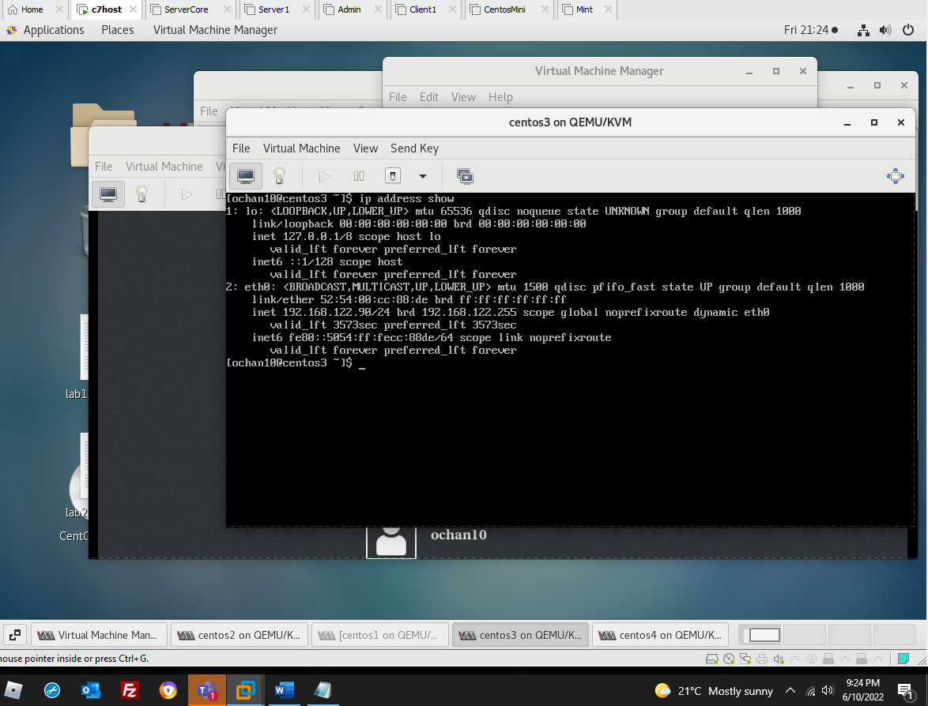

Centos4 ip address:  
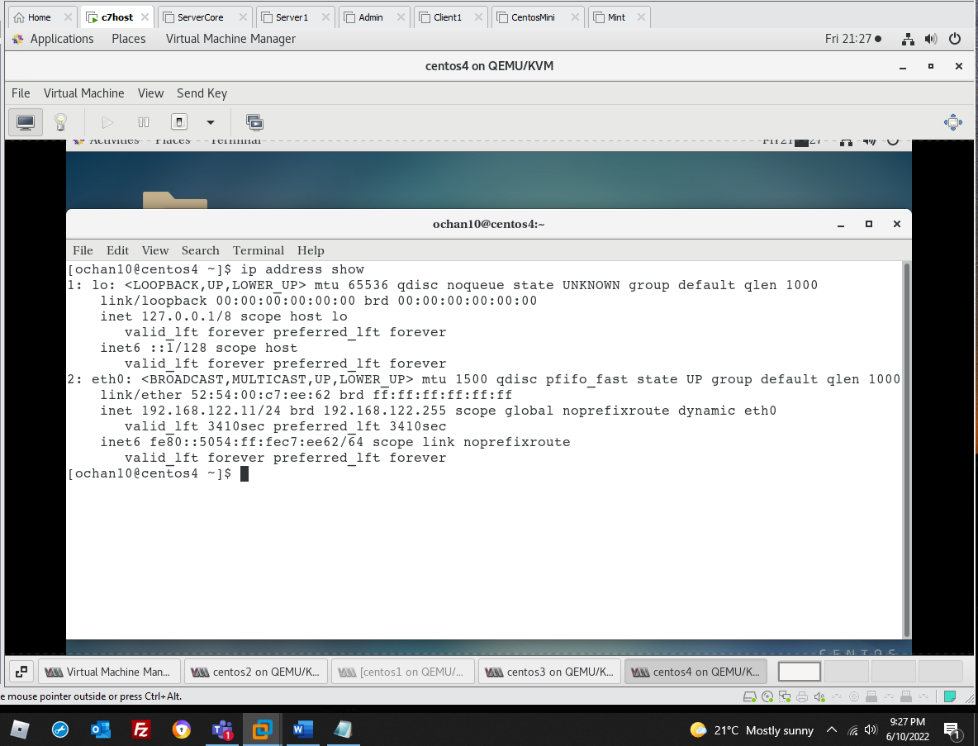

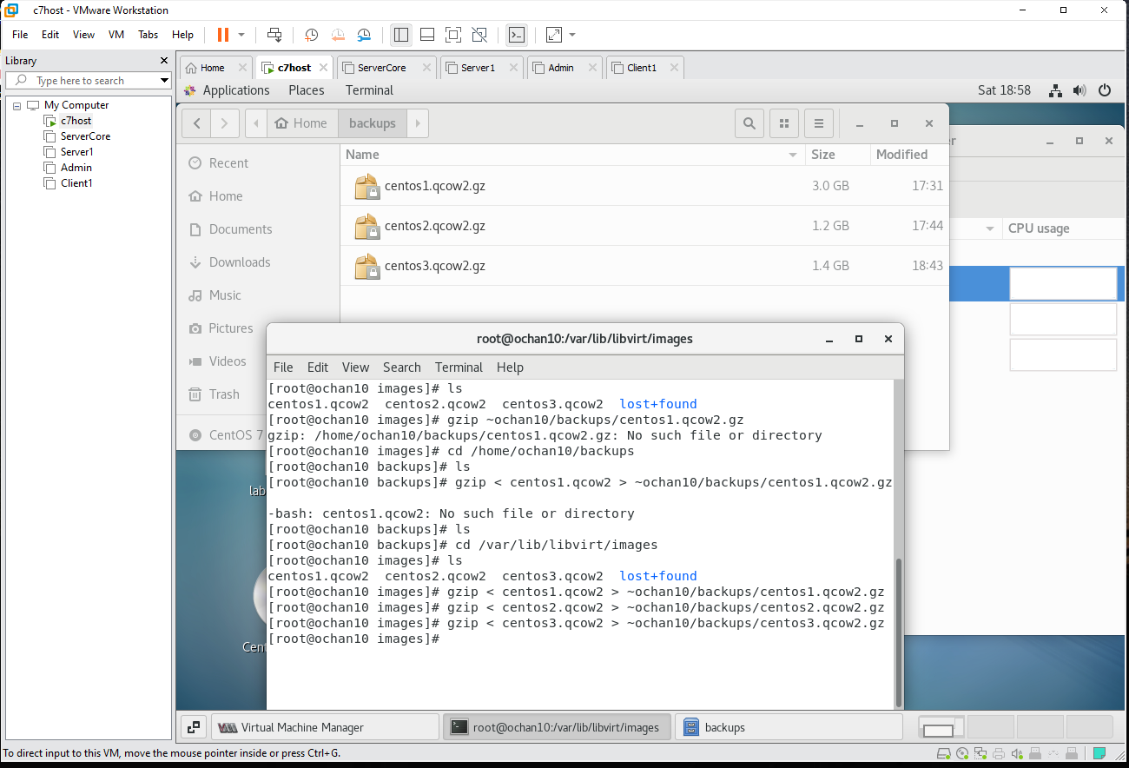

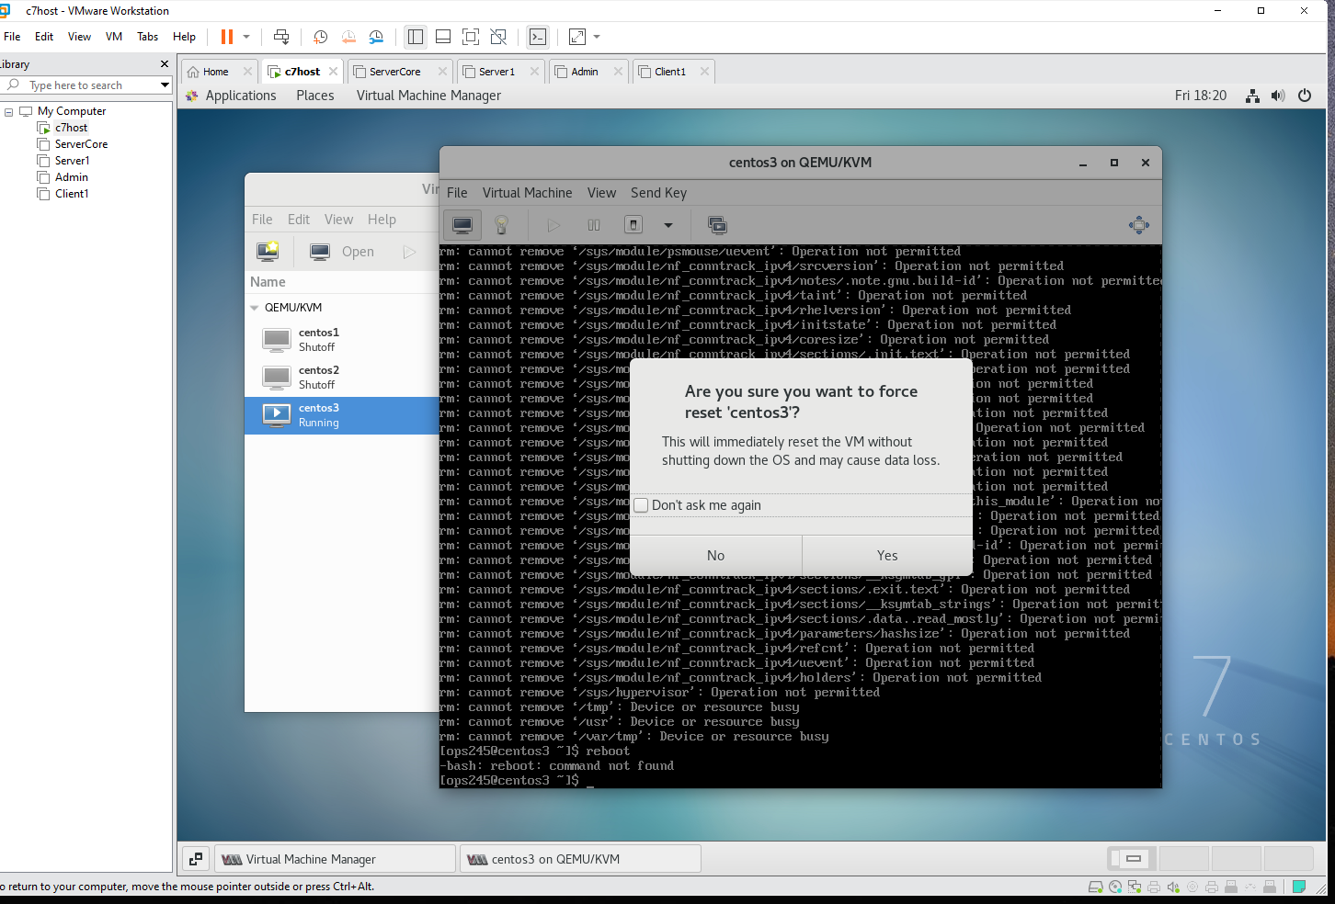

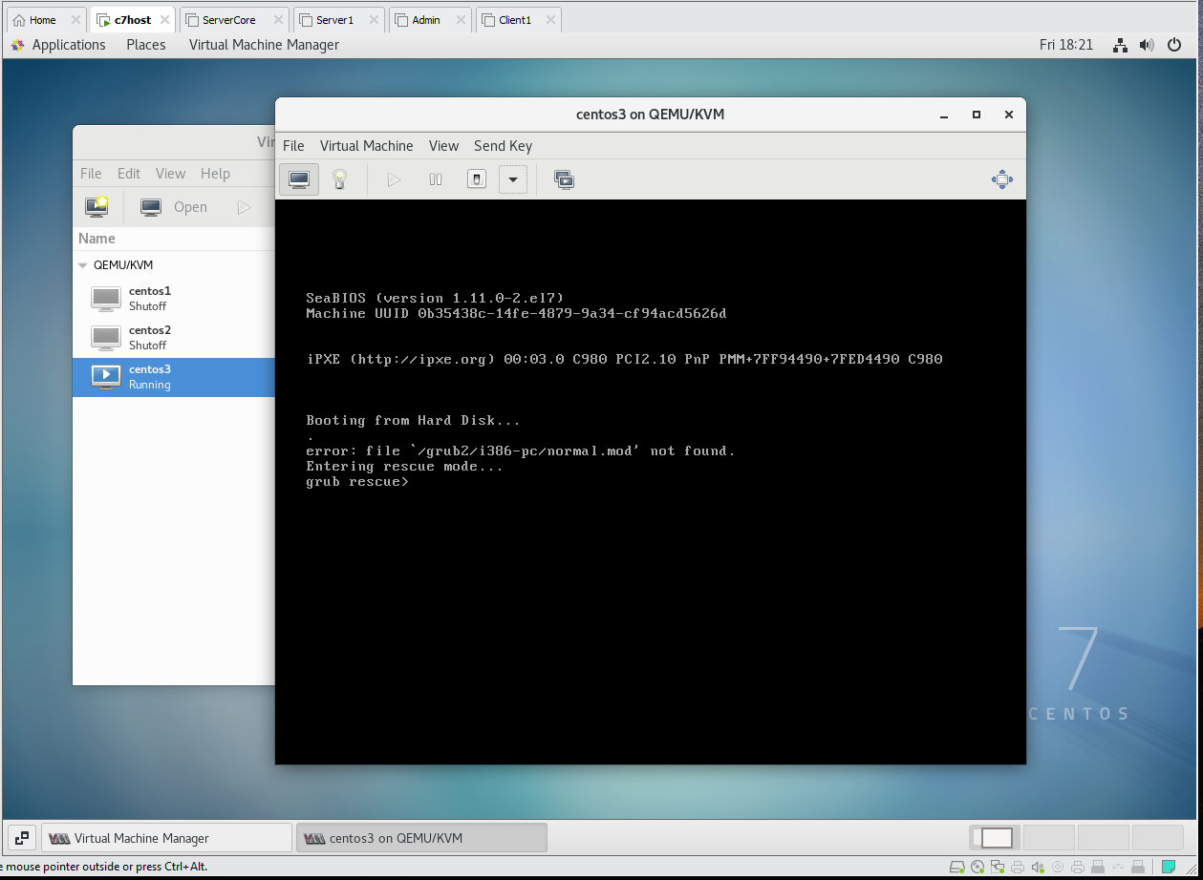

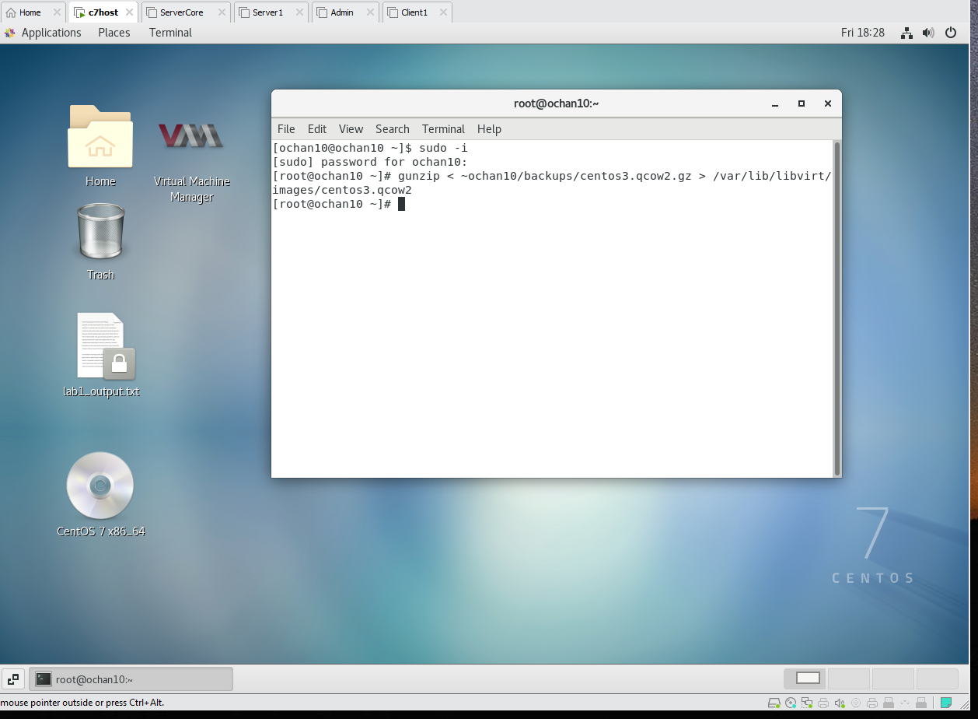

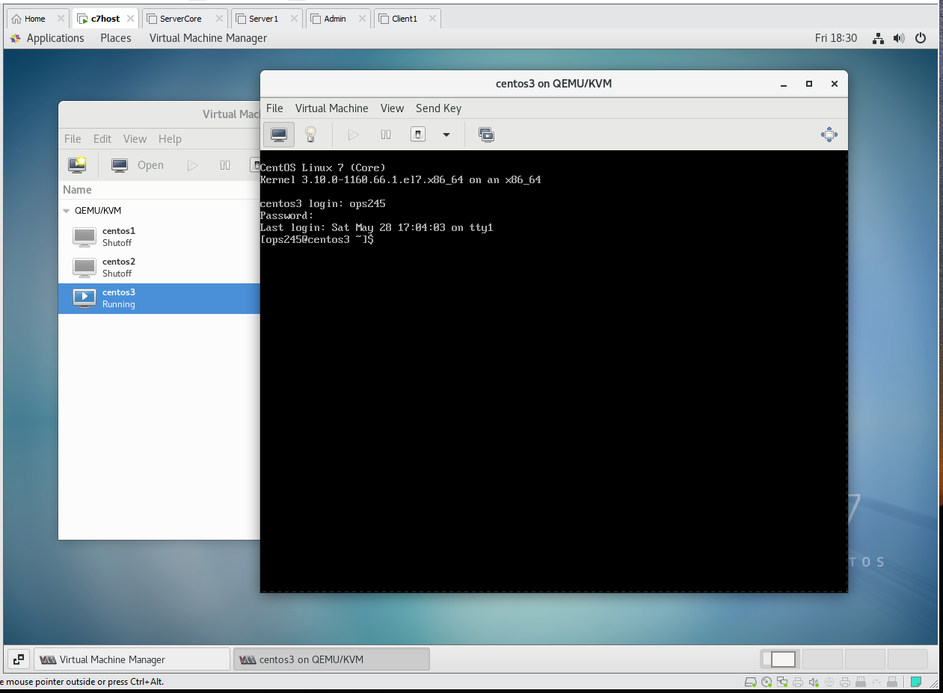

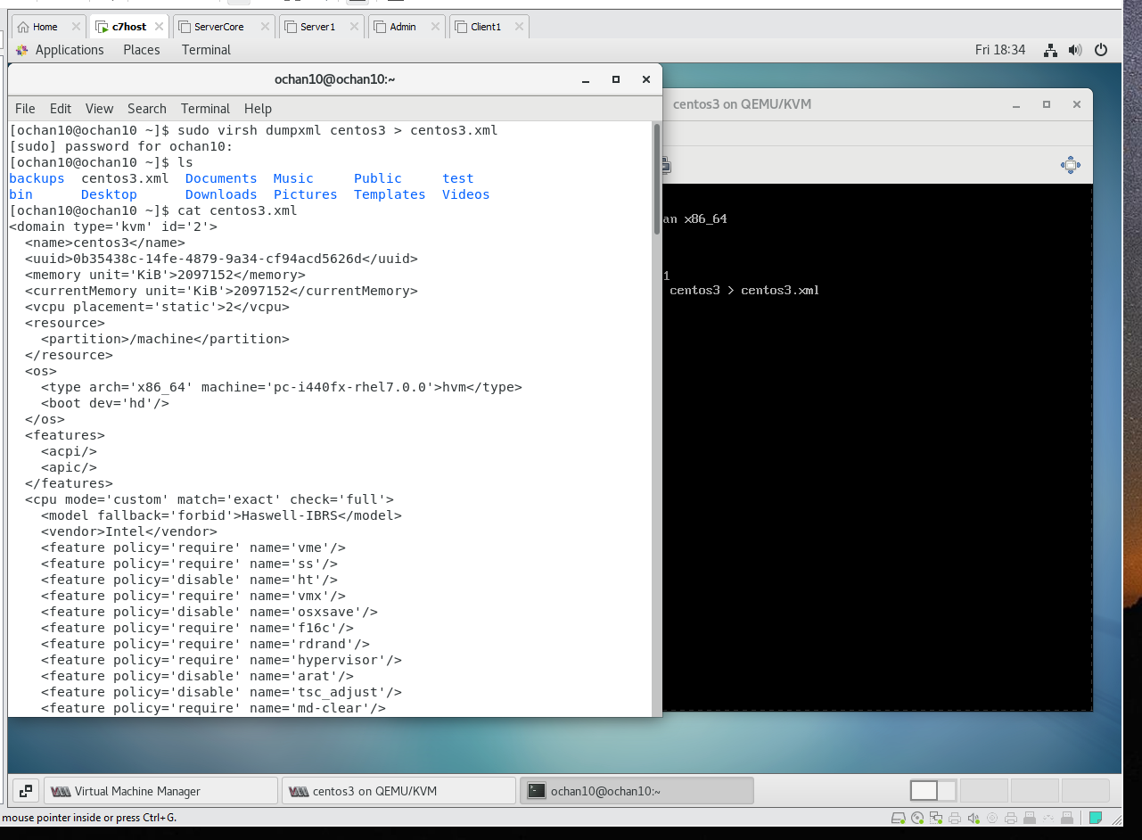

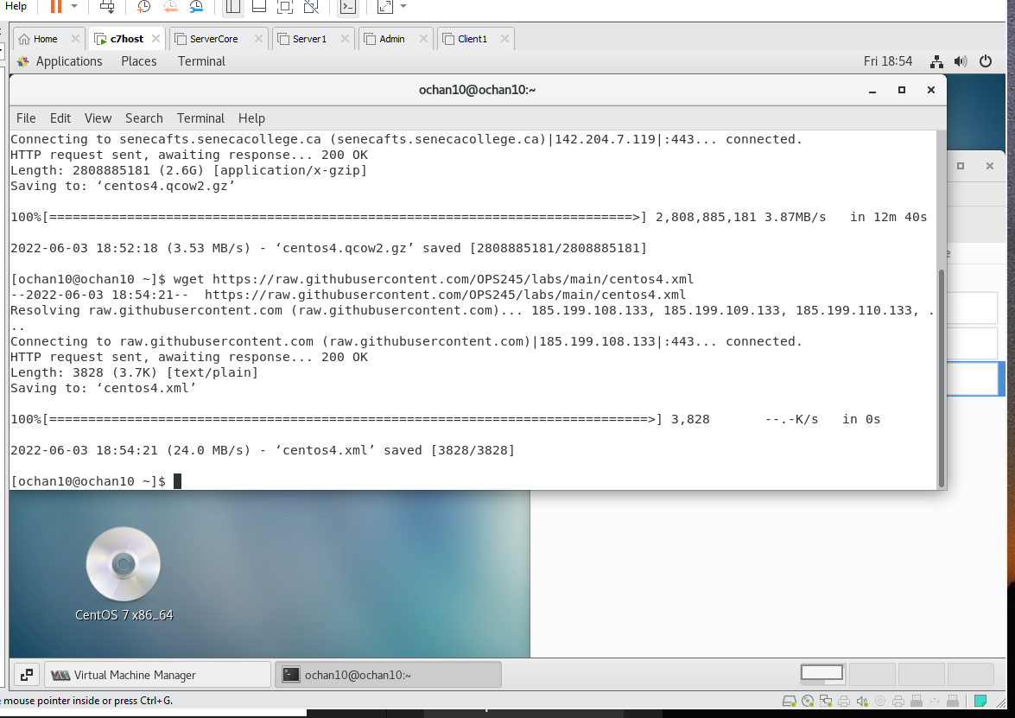

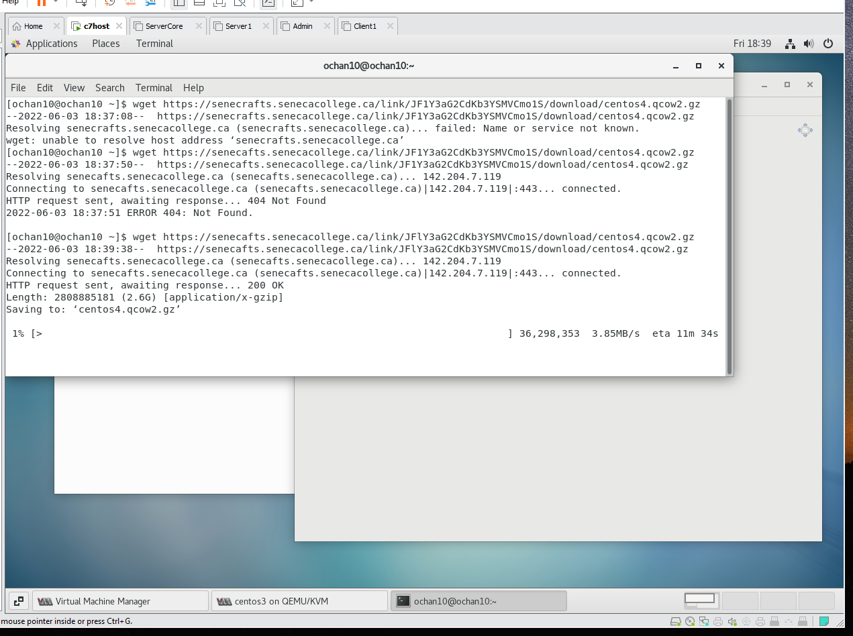

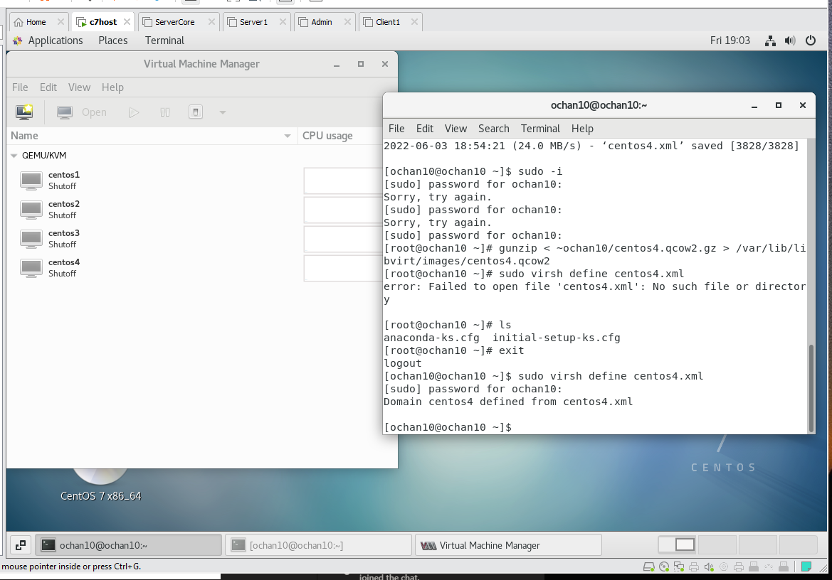

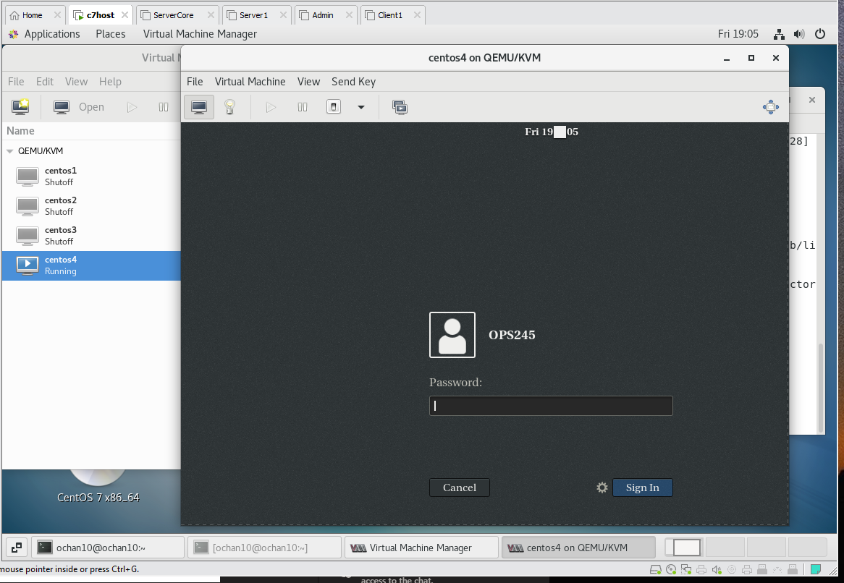

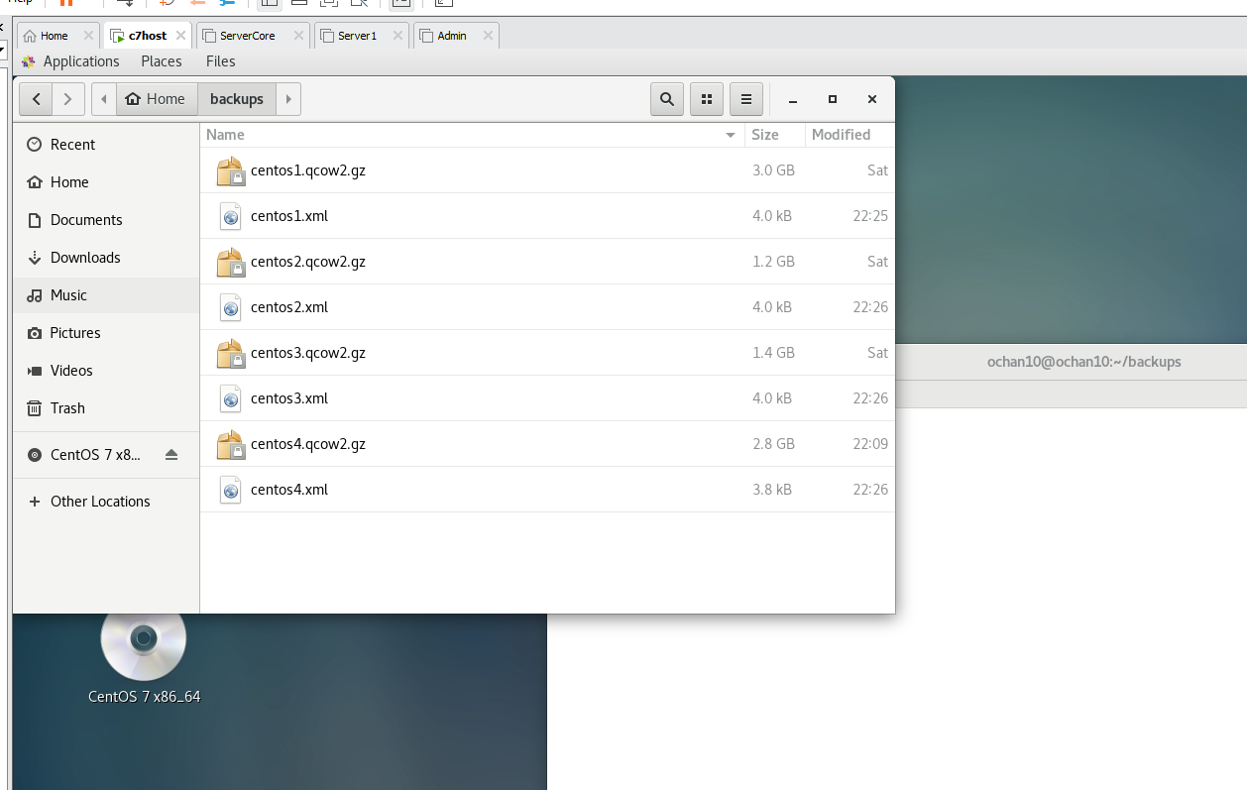

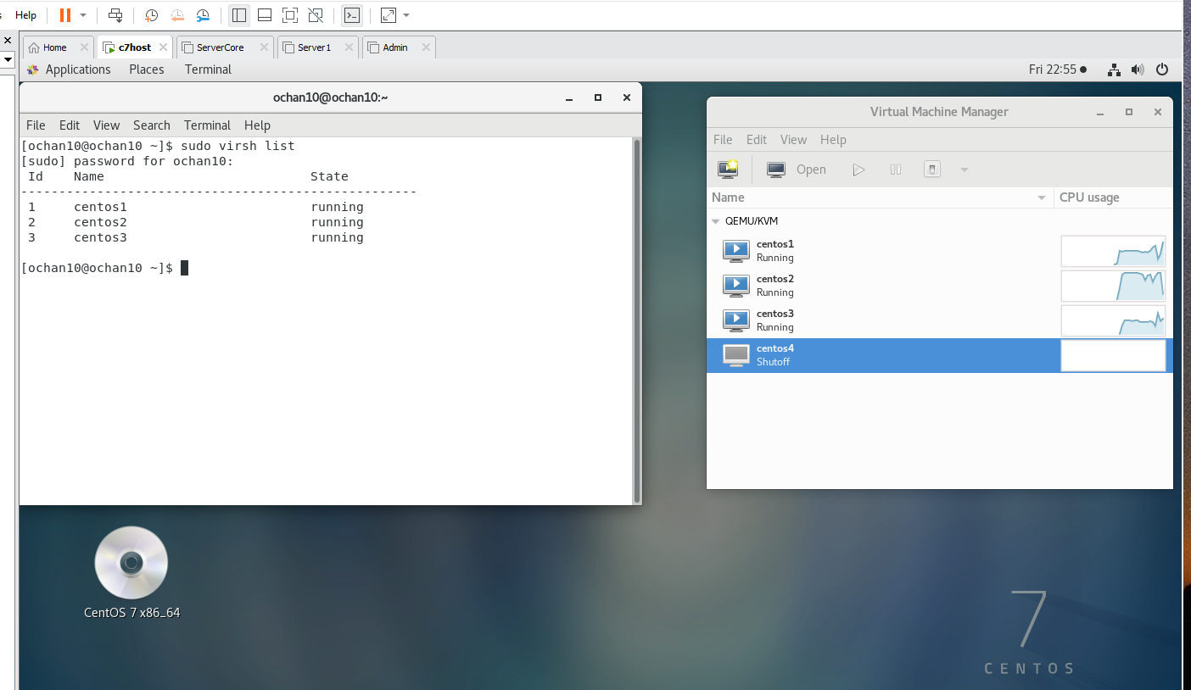

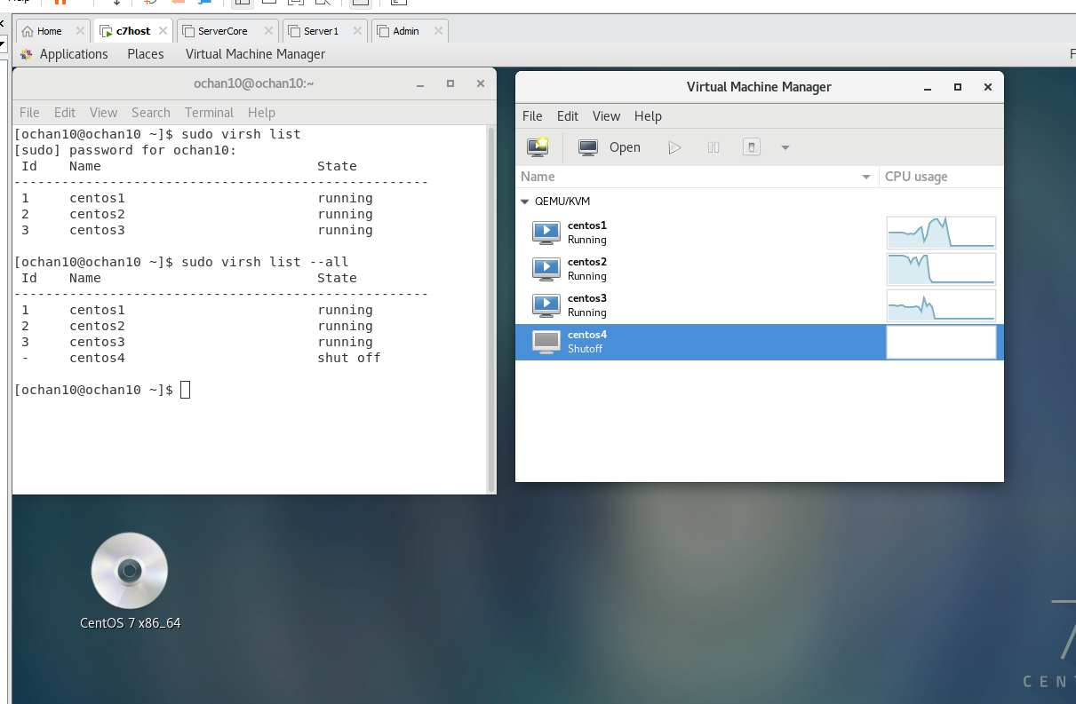

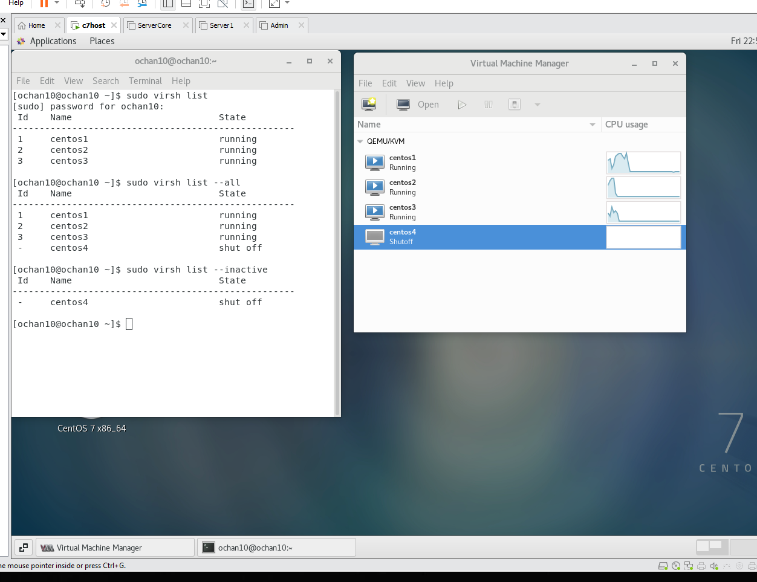

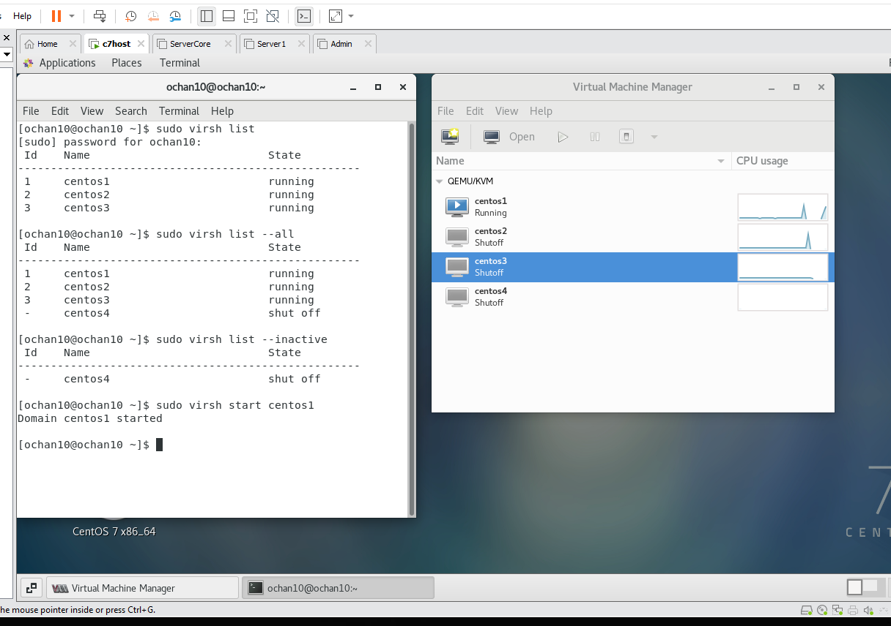

Yum update:

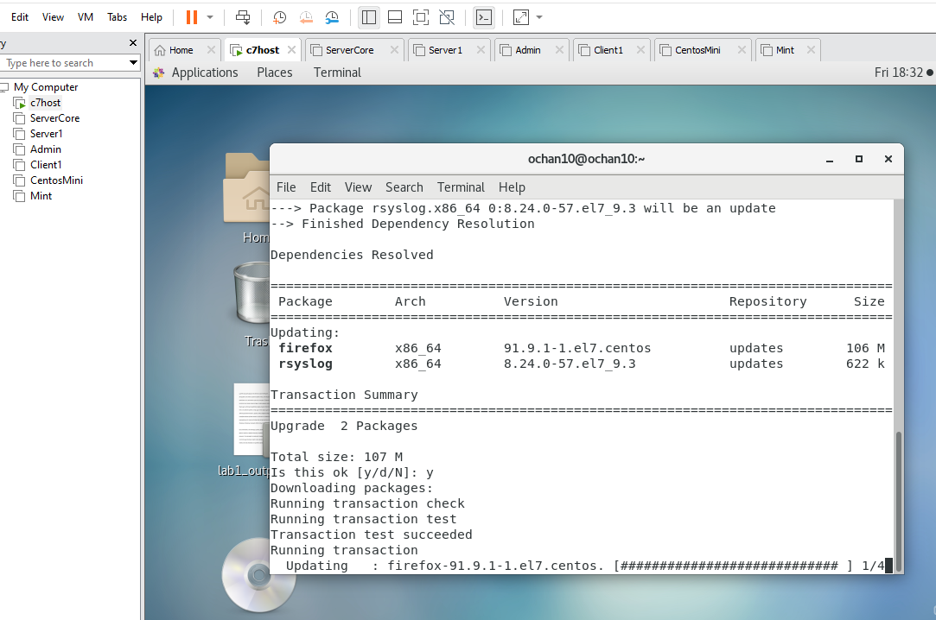

Centos1:

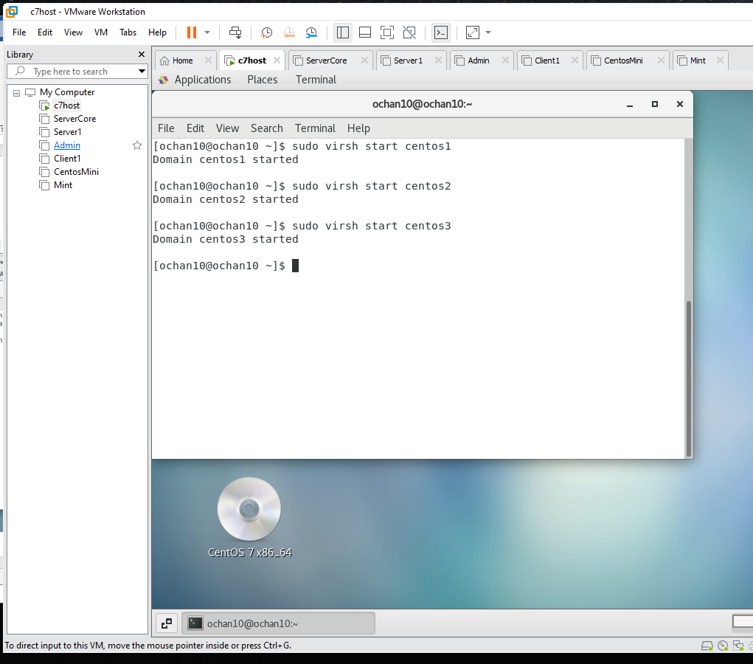

backupVM.py  
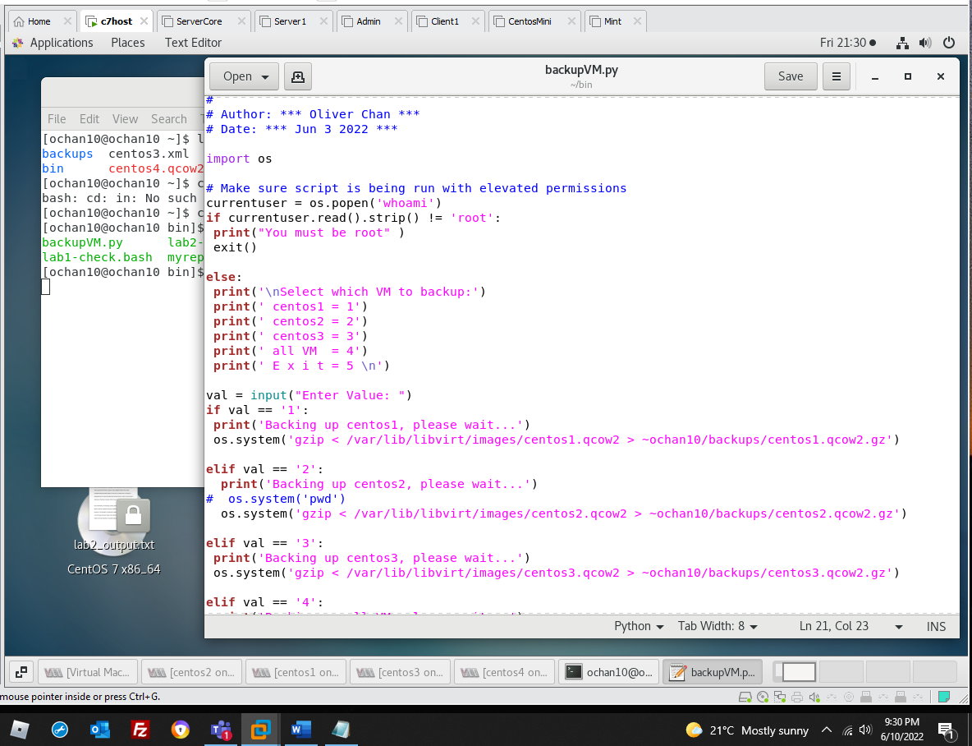

Centos1 yum update  
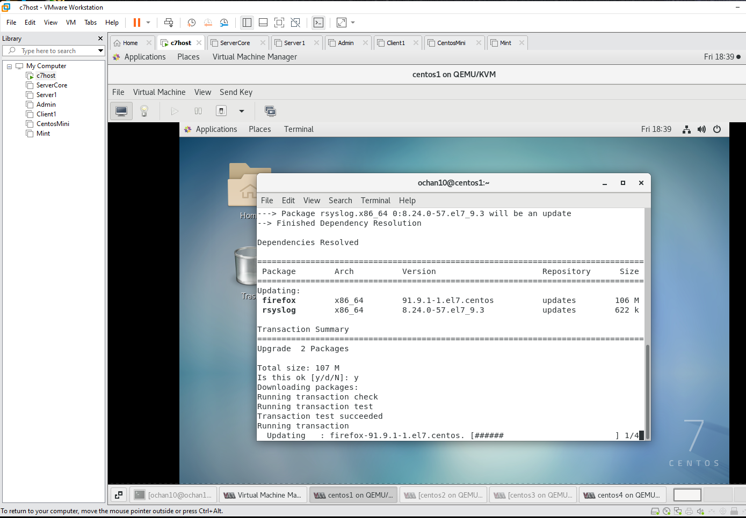

Centos2 yum update:

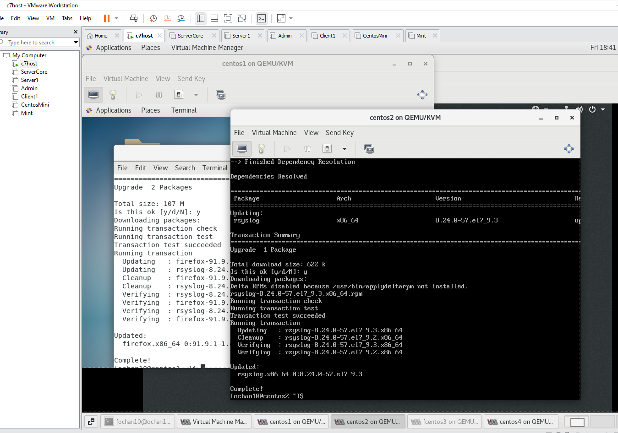

Centos4 yum update:  
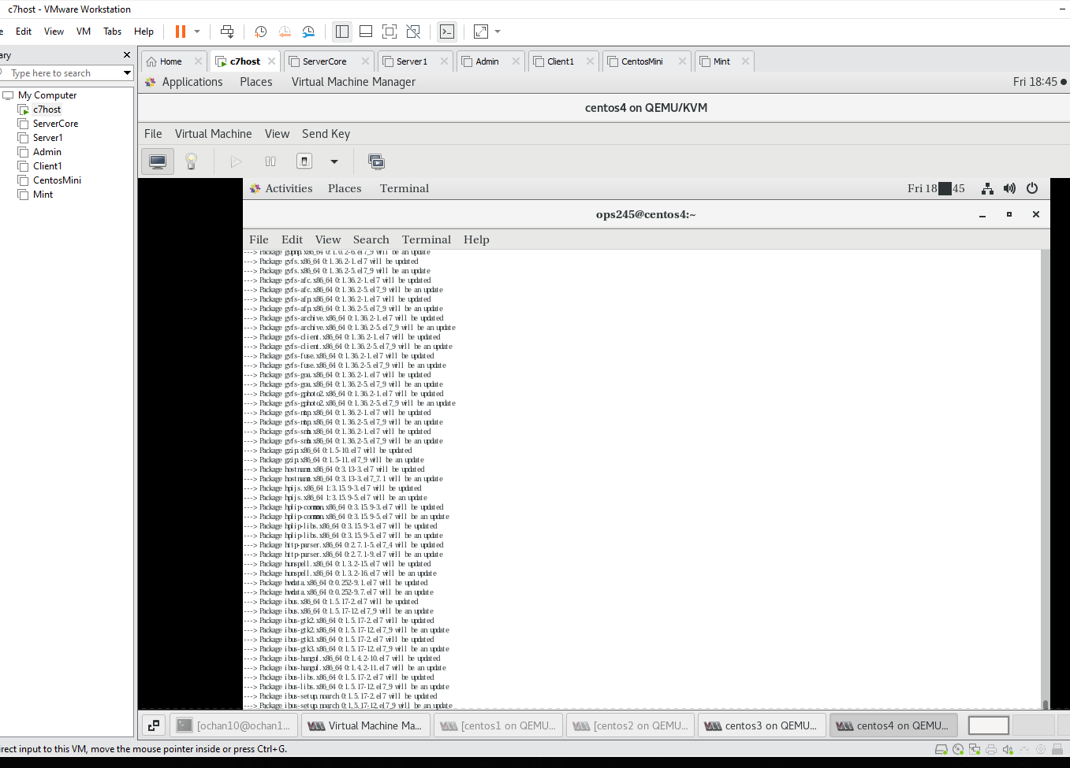

Lab2-check.bash script report:

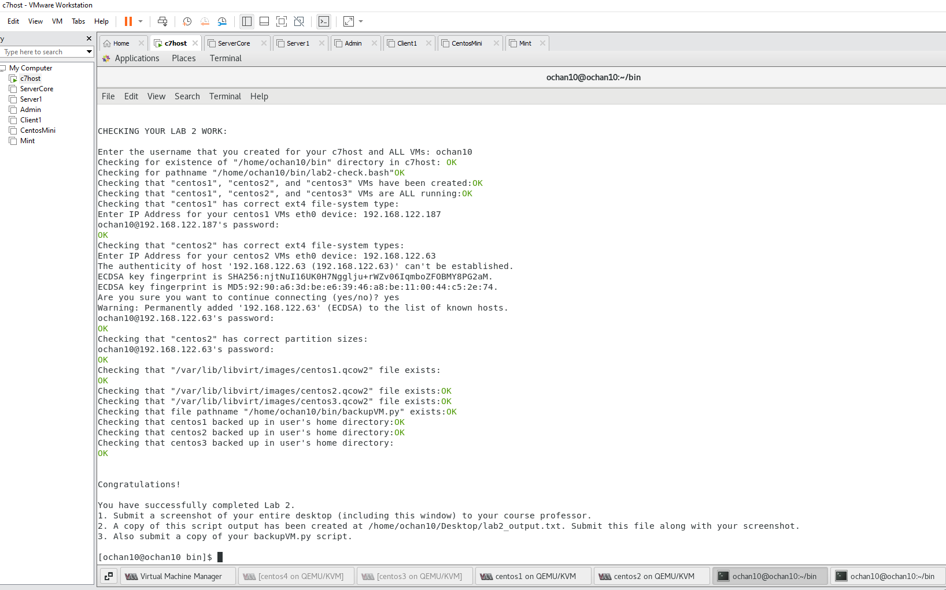

Running backupVM.py screenshot:  
